# **Name: Abdurrahman Qureshi**

# **Roll No: 210451**

Practical No: 4

1) Check whether a number is even or odd.

Code:

inputNum = int(input("Enter your number: "))  
if inputNum % 2 == 0:  
 print("Your entered number, ", inputNum, " : even number! we.......")  
else:  
 print("Your entered number, ", inputNum, " : odd number! bruh")

Output:

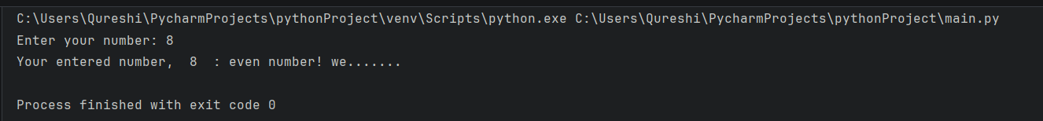

2) Find out absolute value of an input number.

Code:

inputNum = int(input("Enter your number: "))  
absVal = inputNum  
if inputNum < 0:  
 absVal = inputNum * (-1)  
print("The absolute value of ", inputNum, " is ", absVal)

Output:

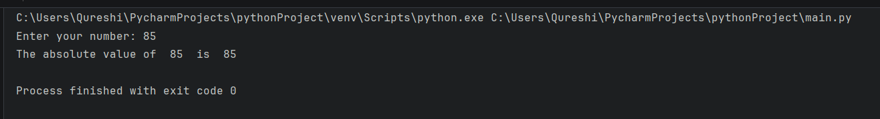

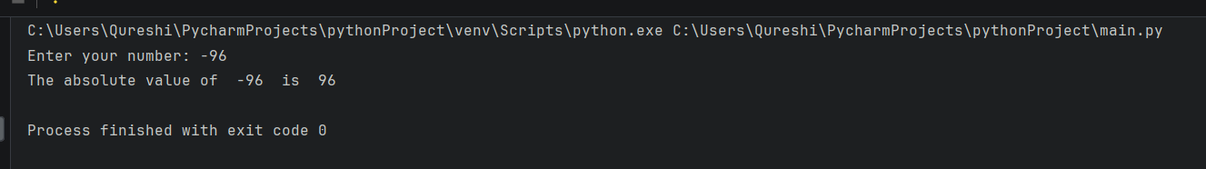

3) Check the largest number among three numbers.

Code:

a = int(input("Enter the first number: "))  
b = int(input("Enter the second number: "))  
c = int(input("Enter the third number: "))  
if a > b and a > c:  
 print(a, " is the greatest of the three contenders! Hail ", a, "!")  
elif b > c:  
 print(b, " is the greatest of the three contenders! Hail ", b, "!")  
else:  
 print(c, " is the greatest of the three contenders! Hail ", c, "!")

Output:

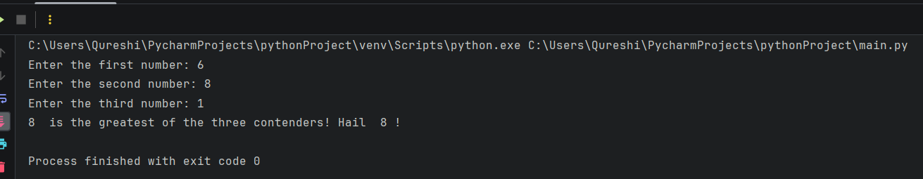

4) Check if input year is a leap year or not.

Code:

n = int(input("Enter the year: "))  
if n % 4 == 0:  
 print("Its: ", n, " is a leap year!")  
else:  
 print(n, " is not a leap year")

Output:

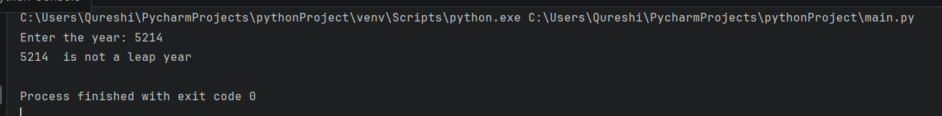

5) Check if a number is positive, negative or zero.

Code:

n = int(input("Enter your number: "))  
if n > 0:  
 print(n, " is a positive number.")  
elif n < 0:  
 print(n, " is a negative number.")  
else:  
 print(n, " is zero.")

Output:

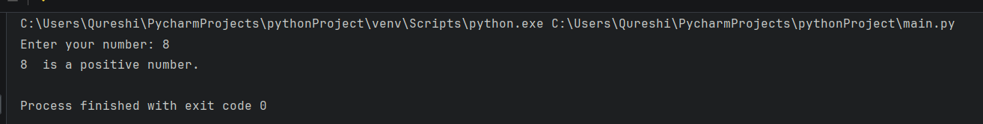

6) Program that takes the marks of 5 subjects and displays the grade.

Code:

s1 = float(input("Enter the marks for subject 1: "))  
s2 = float(input("Enter the marks for subject 2: "))  
s3 = float(input("Enter the marks for subject 3: "))  
s4 = float(input("Enter the marks for subject 4: "))  
s5 = float(input("Enter the marks for subject 5: "))  
AVG = (s1 + s2 + s3 + s4 + s5) / 5  
print("AVG: ", AVG)  
if AVG >= 75:  
 print("The final grade is A. Congratulations!")  
elif AVG >= 65:  
 print("The final grade is B. Impressive!")  
elif AVG >= 45:  
 print("The final grade is C. AVG.")  
elif AVG >= 35:  
 print("The final grade is D. Rather poor.")  
else:  
 print("The final grade is F. You have failed.")

Output:

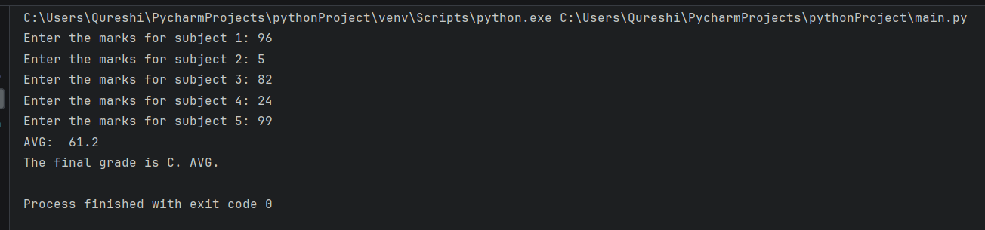

*Extras*

7) Check if entered password is correct or not.

Code:

n = input("What's the password?\nPassword: ")  
if n == "wigga":  
 print("aajao bhai")  
else:  
 print("get the hell out")

Output:

